**Activity Diagram: Process of Making Eggs**

**Basic Activity Diagram:**

The example above is a basic understanding of an activity diagram. It gives us a visual representation of the workflow to make eggs. However, it can get more advanced when you think about decisions. The activity diagram below will take in the decision whether or not the user wants their eggs scrambled or not.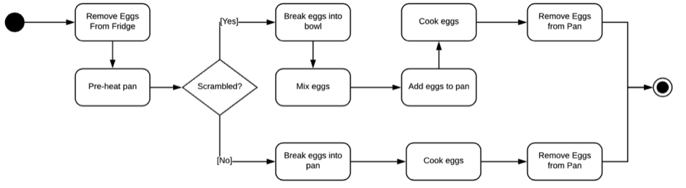

**Why are Activity Diagrams important?**

Activity Diagrams are important because it helps us visualize the workflow of procedural steps to get to your desired end goal. In the SDLC (Software Development Life Cycle), this helps with the “Analysis” phase where it determines the requirements of a system. As simple as making eggs sound, when we think of other requirements of a system (scrambled or not) it will make us more aware of the next steps to get closer to your goal. This helps businesses conceptualize complex systems, which helps with designing, implementing, and debugging or supporting the system to improve the success of the system for future business needs.